**LAB 6 Buổi 2**

flajolet martin algorithm

Source code

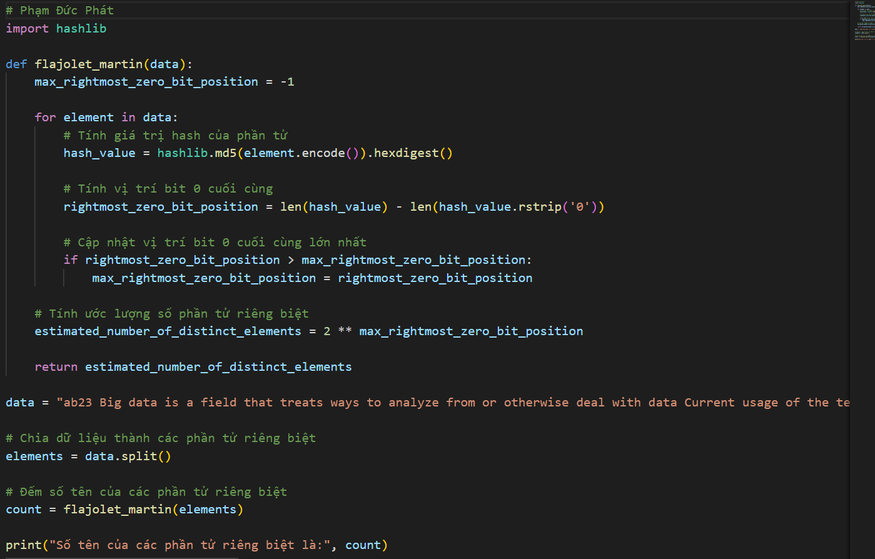

Result

